

Sarah Jean, Alexis Taylor, Ashley Montoya, and Leah Crouch

|  |
| --- |
| Image result for old people hiking |
| Living with COPD  Treatment and Coping information |
| |  |  |  |  | | --- | --- | --- | --- | | Sarah Jean Alexis Taylor Ashley Montoya Leah Crouch |  |  |  | |  |  |  |  | |

**Table of Contents**

What is COPD?.............................................................2

Signs and Symptoms…………………………………..3

Causes of COPD………………………………………….4

Managing your COPD…………………………………5-9

Treatment Options……………………………………10

*Breathing Exercises…………………………………………....10*

*Medications- How to Use Inhalers……………………...12*

*Medications- How do they work?..............................13-16*

Medication Log………………………………………….17

COPD Resources………………………………………..18

Teach Back Questions………………………………...19

References…………………………………………………20

**What is COPD?**

Chronic Obstructive Pulmonary Disorder consists of three disorders: *Asthma, Bronchitis, and Emphysema.* It is one of the most common respiratory diseases. COPD takes time to develop and makes breathing difficult due to damage to the lungs and airways that cannot be reserved.

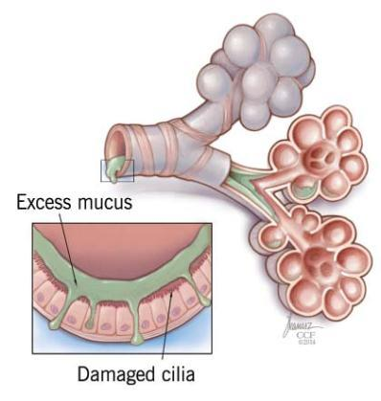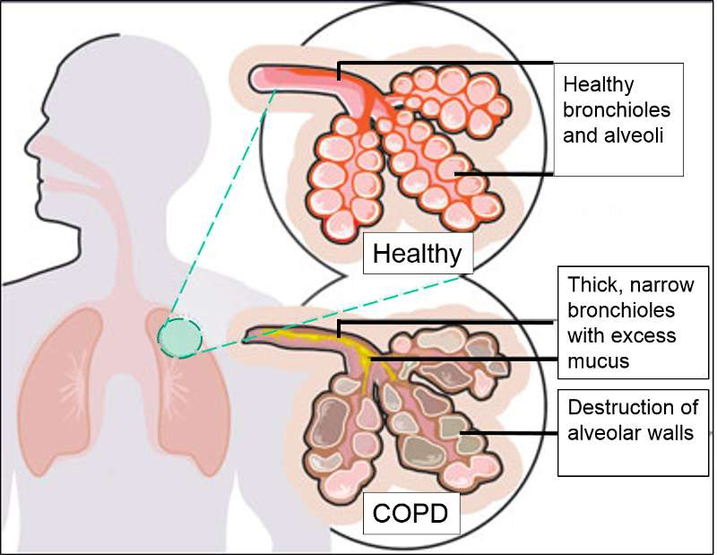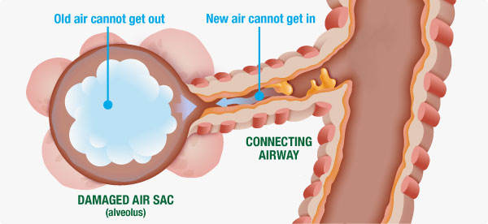

\

**Signs and Symptoms**

* Persistent cough
* Productive cough (a cough that is producing a lot of mucous)
* Shortness of breath, especially with physical activity
* Wheezing, whistling, or squeaking sound with breathing
* Chest tightness

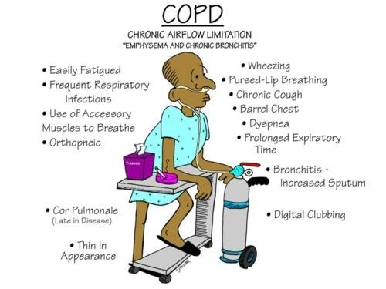

**Causes of COPD**

* Smoking (Including second hand smoking)
* Air pollution
* Dust
* Fumes
* Chemicals
* History of childhood respiratory infection

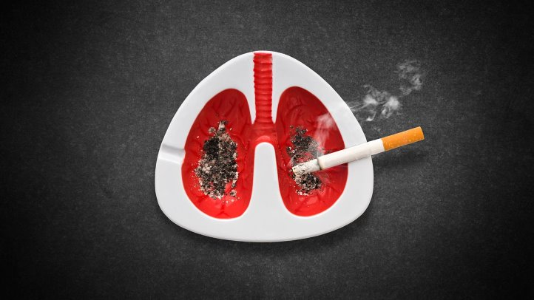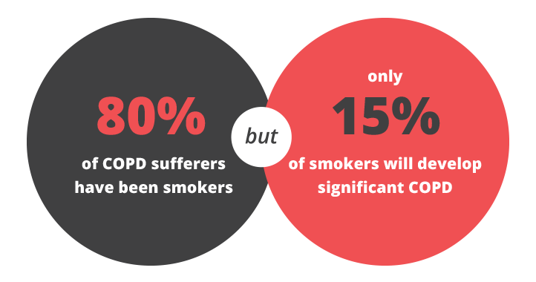

**Managing Your COPD**

Stop Smoking

Smoking is the main cause of COPD, and cigarette smoke is a serious irritant. Ask your doctor for advice about quitting.

Avoid Carpet and Animal Dander,

Particles of fur and skin from pets can cause allergic symptoms. The most effective solution is to keep animals out of your home. If you have pets, you can cut down on the levels of animal dust in your home by vacuuming carpets regularly and keeping pets out of your bedroom. Consider hard-surfaced flooring as a replacement for carpets.

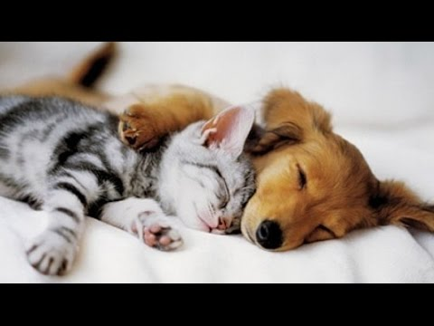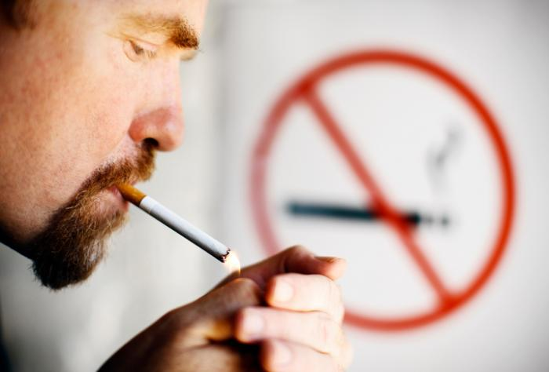

**Managing Your COPD**

Reduce Humidity

Keep all condensation and moisture out of your home. This includes humid air, rain, and groundwater. Install a dehumidifier if necessary. Remember to clean the dehumidifier regularly to avoid a buildup of mildew, mold, and bacteria. Damp conditions irritate COPD.

Avoid Strong Smells

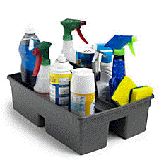Cleaning products, candles, perfumes, laundry detergent, cleaning supplies, aerosols, grooming products, paint, pesticides, and air fresheners, can be irritants. When using products, keep the area well ventilated by opening doors and windows.

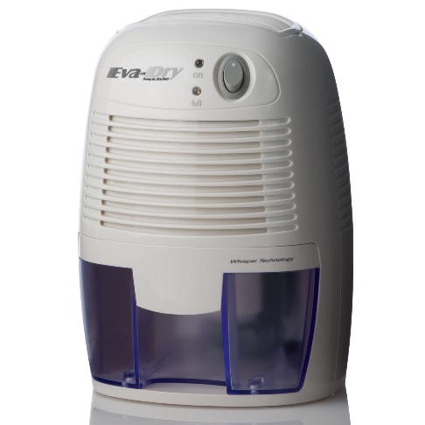

**Managing Your COPD**

Conserve Energy

Instead of standing to perform daily tasks, save your energy by sitting down to get dressed, shave, and brush your teeth. There are also tools available to assist you with putting your socks on if needed.

Breathe Through Tasks

* Slow, deep breaths
* Pursed or diaphragmatic breathing techniques
* Take your time
* Perform one task at a time
* Split large tasks into several smaller ones
* Rest for 20-30 minutes after a task
* Plan ahead to give yourself enough time to go at a comfortable pace



**Managing Your COPD**

Environmental Considerations

* **Cold weather**
  + Wear a scarf over your nose and mouth
* **Pollen**
  + Avoid going outside if possible
  + You can check the local weather report for pollen count
* **Smog** 
  + Avoid outdoor activities if possible
  + You can watch the local news for reports on air quality

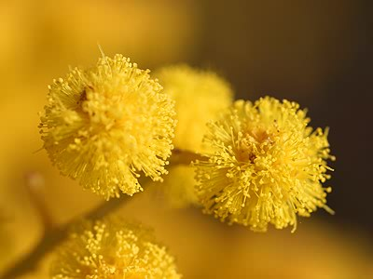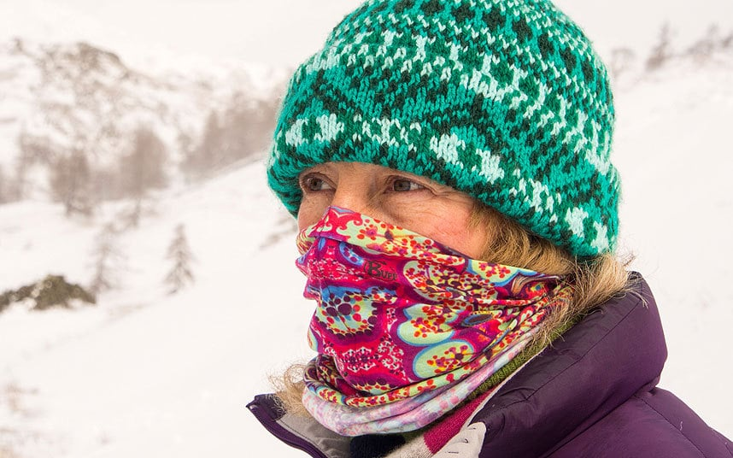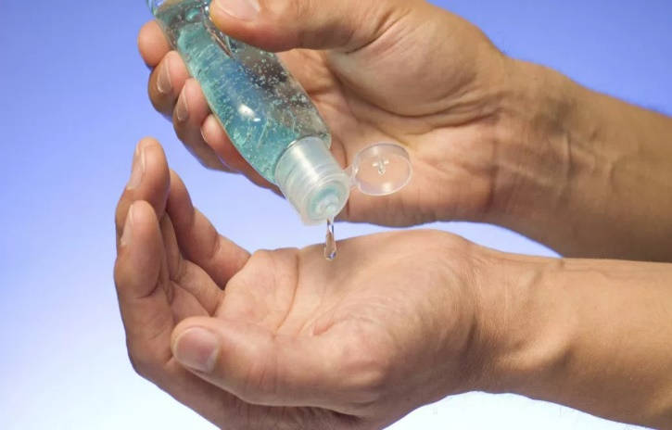

Health Precautions

* + Wash your hands often with soap and water
  + Use hand sanitizer between hand washing. Use after touching public objects
  + Get a Flu Shot each year
  + Get a Pneumonia vaccine
  + Avoid spending time with people who have respiratory illnesses- Avoid crowds and air travel during the winter

**Managing Your COPD**

**Treatment Options**

Breathing Exercises

* Pursed Lip Breathing
* Diaphragmatic Breathing
* 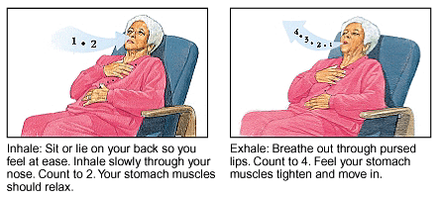Airway Clearance-Coughing Techniques

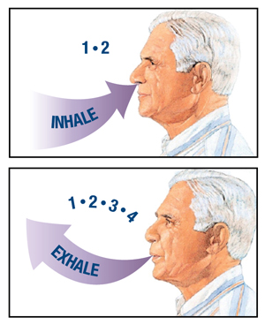

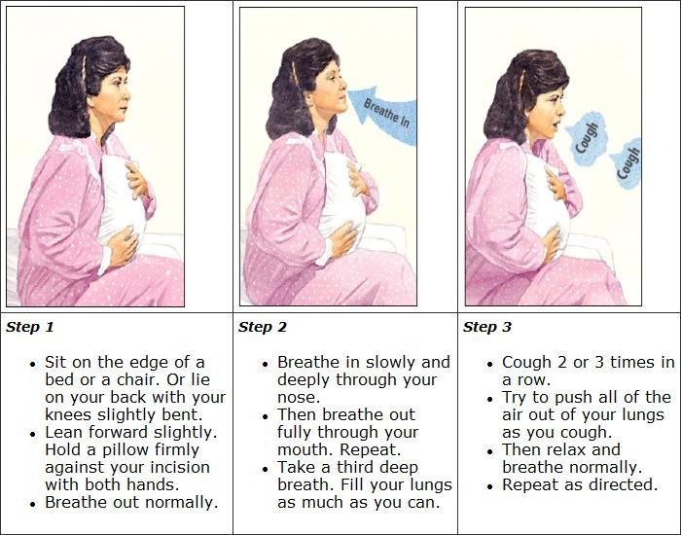

**Treatment Options**

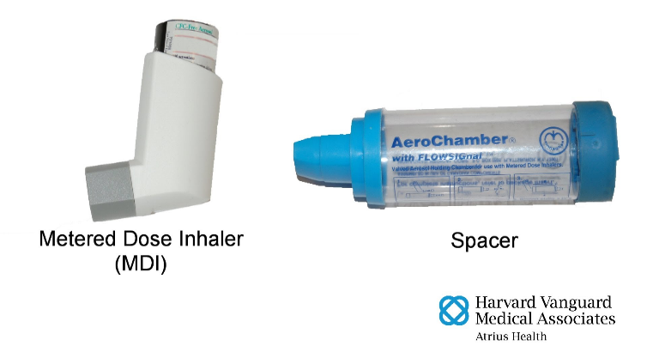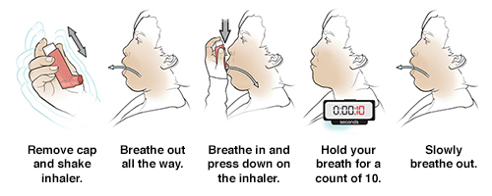

Medications- How to Use Inhalers

* Metered Dose Inhalers:

1. Remove cap from inhaler and spacer. Shake the inhaler and attach the spacer.
2. Breathe out normally. Put the spacer between your teeth and close your lips. Keep your chin up.

Or without spacer:

Breathe out normally. Put the inhaler mouthpiece in your mouth and close your lips. (Or hold the inhaler 1-2 inches from your open mouth). Keep your chin up.

3. Spray 1 puff by pushing down on the inhaler. Slowly breathe in through your mouth a as deeply as you can (3-5 seconds).

 4. Hold your breath for a count of 10. Slowly breathe out. If a second dose is prescribed, wait 1 minute before taking the next puff.

**Treatment Options**

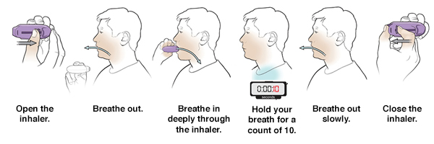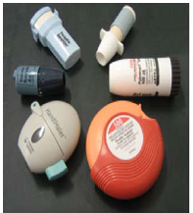

Medications- How to Use Inhalers

* Dry-Powder Inhalers (DPIs)

1. Load the prescribed dose of medication following the inhaler instructions.
2. Breathe out normally. Keep your chin up.
3. Put the mouthpiece between your lips. Breathe in quickly and deeply through your mouth. You may not feel or taste the medication.
4. Hold your breath or a count of 10. Slowly breathe out, but NOT through the inhaler. Moisture can cause the powder to stick inside.
5. Close the inhaler and store it in a dry place.
6. Rinse mouth thoroughly.

**Treatment Options**

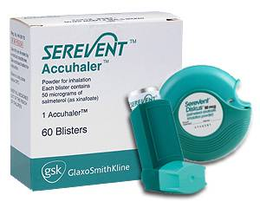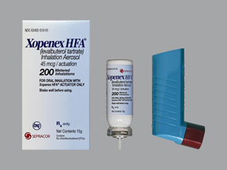

Medications-How They Work

* **Bronchodilators & Anticholinergics (Short-acting)**
  + Examples: Albuterol, Levalbuterol, Ipratropium

***Action***

* + - dilates (opens) airway to increase oxygen influx to lungs
    - relaxes muscles of the airway and lungs
* **Bronchodilators & Anticholinergics (Long-acting)** 
  + Examples: Formoterol, Arformoterol, Salmeterol, Tiotropium

***Action***

* + - dilates (opens) airway to increase oxygen influx to lungs
    - relaxes muscles of the airway and lungs
    - often coupled with corticosteroid therapy

**Treatment Options**

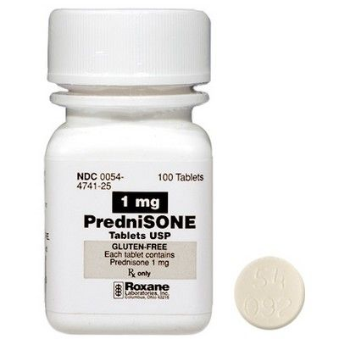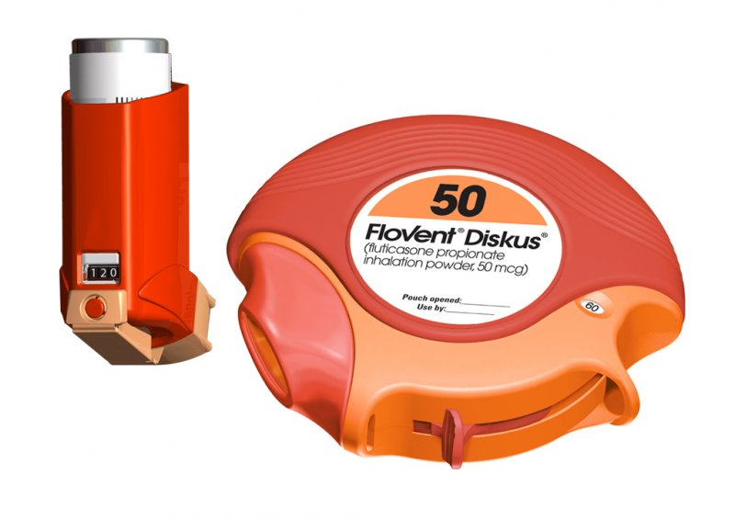

Medications-How They Work

* **Oral Corticosteroids (anti-inflammatory)**
  + Examples: Prednisone, Methylprednisolone

***Action***

* + - reduce inflammation of airway
    - reduces sensitivity of airway to exacerbating factors
    - treats moderate to severe cases
    - usually coupled with a bronchodilator
* **Inhaled Corticosteroids (anti-inflammatory)** 
  + Examples: Fluticasone, Budesonide, Beclomethasone

***Action***

* + - reduces inflammation of airway
    - reduces sensitivity of airway to exacerbating factors

**Treatment Options**

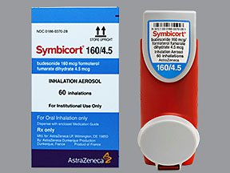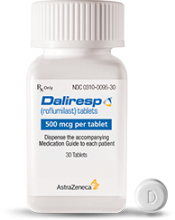

Medications-How they Work

* **Combination-Long-acting bronchodilator & ICS** 
  + Examples: Salmeterol/fluticasone, Formoterol/budesonide

***Action***

* + - dilates (opens) airway to increase oxygen influx to lungs
    - relaxes muscles of the airway and lungs
    - reduces inflammation of airway
    - reduces sensitivity of airway to exacerbating factors
* **Phosphodiesterase-4 Inhibitor** 
  + Example: Roflumilast

***Action***

* + - Limits COPD flare-ups

**Treatment Options**

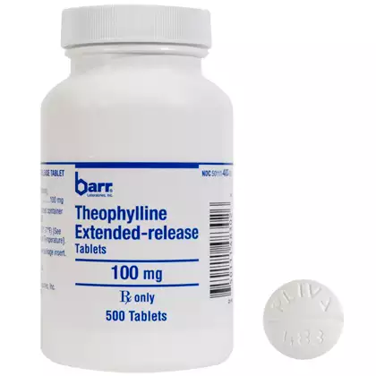

Medications-How They Work

* **Methylxanthines (bronchodilator)** 
  + Example: Theophylline

**Warning**

* + - Monitor blood levels

***Action***

* + - dilates (opens) airway to increase oxygen influx to lungs
    - relaxes muscles of the airway and lungs

**Medication Log**

|  |  |  |  |
| --- | --- | --- | --- |
| **Medication** | **Name of Medicine** | **How Much to Take** | **When to Take It** |
| Rescue Inhaler |  |  |  |
| Controller |  |  |  |
| Controller |  |  |  |
| Inhaled Steroid |  |  |  |
| Nebulizer |  |  |  |

Websites

* Smoke Free: [www.smokefree.gov](http://www.smokefree.gov)
* My Lungs My Life: <http://mylungsmylife.org/i-have-copd/>
* COPD Support: <http://www.copd-support.com/index.htm>
* American Lung Association: [www.Lungsusa.org](http://www.Lungsusa.org)
* Better Breathers Club: <http://www.lung.org/support-and-community/better-breathers-club/>
* COPD Foundation: [www.copdfoundation.org](http://www.copdfoundation.org)
* DRIVE4COPD: [www.drive4copd.org](http://www.drive4copd.org)

Support Groups

* Caregiving Support Community
  + <http://lung.lotsahelpinghands.com/caregiving/home/>

Help Line

* Lung Helpline & Tobacco Outline
  + Website: <http://www.lung.org/support-and-community/lung-helpline-and-tobacco-quitline/>
  + Phone: 1(800) LUNGUSA
  + Hours:  
    Monday-Friday 7 a.m.-9 p.m. CT  
    Weekends 9 a.m.-5 p.m.

Online Support Community

* + <http://www.lung.org/support-and-community/online-support-communities/>

**Patient Resources**

1. What should you do if you have difficulty breathing?
2. What warning signs should you report?
3. Show me your rescue inhaler
   1. When should you use it?
4. Show me your controller inhaler
   1. When should you use it
5. What is a breathing exercise you can do?
6. Name some resources to get more information on COPD.

**Teach Back Questions**

**References**

Bon Secours Virginia Health System. (2015). *Good for your lungs.*

COPD. (n.d.). Retrieved February 15, 2018, from https://www.nhlbi.nih.gov/health-topics/copd

What Causes COPD. (n.d.). Retrieved February 15, 2018, from

http://www.lung.org/lung-health-and-diseases/lung-disease-lookup/copd/symptoms-causes-risk-factors/what-causes-copd.html?referrer=https%3A%2F%2Fwww.google.com%2F